

**Care Templates**

**Why is this Section Important?**

Organization will lighten your load! This section is filled with some tools, templates, and resources that can be used to support you in organizing and managing your day-to-day routine and activities.

**How to Use this Section**

Use and adapt this section to fit your needs. Every healthcare journey is different.

**How Friends and Family Can Help**

This template provides a resource to use when looking for support. People may offer to help out, but do not know how they can contribute. Keeping a list of duties that you may need support for can serve as a great quick reference resource. Consider letting others have a role to help you complete some of the tasks that you have on your list. Many hands make light work!

**Meal Planning Chart**

Meal planning is an easy way to save on time. Meal planning has additional benefits including saving money, eating better, and less trips to the grocery store and time cooking. If you or someone you are caring for needs help at meals, this can be a good place to write who and when help is needed.

**Daily Routines**

This template has been created to record your daily routines. This may be helpful if you have a complicated schedule, or if you require care from multiple people. If you have a caregiver or health providers coming into your home, recording your plan serves as a back-up if you become unavailable to provide care – others can look at the schedule help out as needed.

**Body Diagram**

The body diagram template can be used to track pain, sensation, strength or anything else that is relevant to you or the person you are caring for.

**Typical Week**

This is a template for recording your daily routine. This can be helpful as healthcare providers are coming and going to help share with them the tasks that need to be done each day.

**Household Routines and Preferences**

This template is used to record routines and preferences. For example, do you prefer the temperature of the house is kept a certain way? The blinds are drawn at a particular time? Do you have food preparation preferences (e.g. food should not touch)? These tips about preferences can make the difference in quality of care for you or the person you are caring for and can be shared with anyone who comes into the home.

**Calendar Templates**

Keeping a calendar is essential to staying organized. This can help you know where you need to go each day and when. Keeping on top of this information can relieve stress, help you prepare for appointments, and avoid double booking. Having a calendar also helps to recognize in advance which days they might need extra support. Use the blank templates, or your own calendar, to keep track of appointments, procedures, hospitalizations, meetings etc. The calendar can be used in any way that suits you.

The templates included in this section are just the start of potential templates that you may find or create to help you on your journey. Feel free to add, modify or replace any contents of this binder with resources that suit your journey.

|  |  |
| --- | --- |
| **Task** | **Who Can Help** |
| *e.g. Mowing the Lawn* | *e.g. George - Neighbour* |
|  |  |
|  |  |
|  |  |
|  |  |
|  |  |
|  |  |
|  |  |
|  |  |
|  |  |
|  |  |
|  |  |

**Date Range:** ____________________________________

**Allergies/Dietary Restrictions:**

____________________________________________________________________________________________________________

**Preferences or Considerations:**

____________________________________________________________________________________________________________

|  |  |  |  |
| --- | --- | --- | --- |
|  | Monday | Tuesday | Wednesday |
| Breakfast | 🞏 Meal Support Time:_________ | 🞏 Meal Support Time:_________ | 🞏 Meal Support Time:_________ |
| Snack | 🞏 Meal Support Time:_________ | 🞏 Meal Support Time:_________ | 🞏 Meal Support Time:_________ |
| Lunch | 🞏 Meal Support Time:_________ | 🞏 Meal Support Time:_________ | 🞏 Meal Support Time:_________ |
| Snack | 🞏 Meal Support Time:_________ | 🞏 Meal Support Time:_________ | 🞏 Meal Support Time:_________ |
| Dinner | 🞏 Meal Support Time:_________ | 🞏 Meal Support Time:_________ | 🞏 Meal Support Time:_________ |
| Snack | 🞏 Meal Support Time:_________ | 🞏 Meal Support Time:_________ | 🞏 Meal Support Time:_________ |

|  |  |  |  |  |
| --- | --- | --- | --- | --- |
|  | Thursday | Friday | Saturday | Sunday |
| Breakfast | 🞏 Meal Support Time:_________ | 🞏 Meal Support Time:_________ | 🞏 Meal Support Time:_________ | 🞏 Meal Support Time:_________ |
| Snack | 🞏 Meal Support Time:_________ | 🞏 Meal Support Time:_________ | 🞏 Meal Support Time:_________ | 🞏 Meal Support Time:_________ |
| Lunch | 🞏 Meal Support Time:_________ | 🞏 Meal Support Time:_________ | 🞏 Meal Support Time:_________ | 🞏 Meal Support Time:_________ |
| Snack | 🞏 Meal Support Time:_________ | 🞏 Meal Support Time:_________ | 🞏 Meal Support Time:_________ | 🞏 Meal Support Time:_________ |
| Dinner | 🞏 Meal Support Time:_________ | 🞏 Meal Support Time:_________ | 🞏 Meal Support Time:_________ | 🞏 Meal Support Time:_________ |
| Snack | 🞏 Meal Support Time:_________ | 🞏 Meal Support Time:_________ | 🞏 Meal Support Time:_________ | 🞏 Meal Support Time:_________ |

|  |  |
| --- | --- |
| **For Me** | **For My Caregiver** |
| Monday | Monday |
| Tuesday | Tuesday |
| Wednesday | Wednesday |
| Thursday | Thursday |
| Friday | Friday |
| Saturday | Saturday |
| Sunday | Sunday |

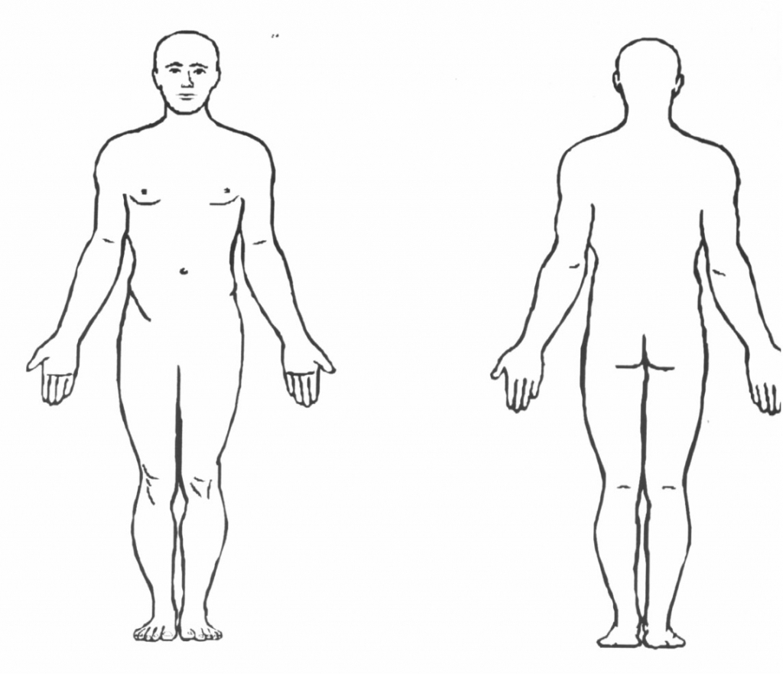

|  |  |  |  |  |
| --- | --- | --- | --- | --- |
|  | Monday | Tuesday | Wednesday | Thursday |
| Morning |  |  |  |  |
|  |  |  |  |
|  |  |  |  |
|  |  |  |  |
|  |  |  |  |
|  |  |  |  |
| Afternoon |  |  |  |  |
|  |  |  |  |
|  |  |  |  |
|  |  |  |  |
|  |  |  |  |
| Night |  |  |  |  |
|  |  |  |  |
|  |  |  |  |
|  |  |  |  |
|  |  |  |  |

|  |  |  |  |
| --- | --- | --- | --- |
|  | Friday | Saturday | Sunday |
| Morning |  |  |  |
|  |  |  |
|  |  |  |
|  |  |  |
|  |  |  |
|  |  |  |
| Afternoon |  |  |  |
|  |  |  |
|  |  |  |
|  |  |  |
|  |  |  |
| Night |  |  |  |
|  |  |  |
|  |  |  |
|  |  |  |
|  |  |  |

|  |
| --- |
| **Household Routines and Preferences** |
| *e.g. Please wash your hands in the bathroom sink instead of the kitchen sink*  *e.g. Please leave the thermostat at 22°C* |
|  |
|  |
|  |
|  |
|  |
|  |
|  |
|  |
|  |

**Month: Year:**

|  |  |  |  |  |  |  |  |  |  |  |  |  |  |
| --- | --- | --- | --- | --- | --- | --- | --- | --- | --- | --- | --- | --- | --- |
| Sunday | | Monday | | Tuesday | | Wednesday | | Thursday | | Friday | | Saturday | |
|  |  |  |  |  |  |  |  |  |  |  |  |  |  |
|  |  |  |  |  |  | |  |
|  |  |  |  |  |  |  |  |  |  |  |  |  |  |
|  | |  |  |  |  |  |  | |
|  |  |  |  |  |  |  |  |  |  |  |  |  |  |
|  | |  | |  |  |  |  | |  |
|  |  |  |  |  |  |  |  |  |  |  |  |  |  |
|  | |  | |  |  | |  |  |  | |
|  |  |  |  |  |  |  |  |  |  |  |  |  |  |
|  |  | |  |  | |  |  | |  | |
|  |  |  |  |  |  |  |  |  |  |  |  |  |  |
|  |  | |  |  | |  |  | |  | |

**Month: Year:**

|  |  |  |  |  |  |  |  |  |  |  |  |  |  |
| --- | --- | --- | --- | --- | --- | --- | --- | --- | --- | --- | --- | --- | --- |
| Sunday | | Monday | | Tuesday | | Wednesday | | Thursday | | Friday | | Saturday | |
|  |  |  |  |  |  |  |  |  |  |  |  |  |  |
|  |  |  |  |  |  | |  |
|  |  |  |  |  |  |  |  |  |  |  |  |  |  |
|  | |  |  |  |  |  |  | |
|  |  |  |  |  |  |  |  |  |  |  |  |  |  |
|  | |  | |  |  |  |  | |  |
|  |  |  |  |  |  |  |  |  |  |  |  |  |  |
|  | |  | |  |  | |  |  |  | |
|  |  |  |  |  |  |  |  |  |  |  |  |  |  |
|  |  | |  |  | |  |  | |  | |
|  |  |  |  |  |  |  |  |  |  |  |  |  |  |
|  |  | |  |  | |  |  | |  | |

**Month: Year:**

|  |  |  |  |  |  |  |  |  |  |  |  |  |  |
| --- | --- | --- | --- | --- | --- | --- | --- | --- | --- | --- | --- | --- | --- |
| Sunday | | Monday | | Tuesday | | Wednesday | | Thursday | | Friday | | Saturday | |
|  |  |  |  |  |  |  |  |  |  |  |  |  |  |
|  |  |  |  |  |  | |  |
|  |  |  |  |  |  |  |  |  |  |  |  |  |  |
|  | |  |  |  |  |  |  | |
|  |  |  |  |  |  |  |  |  |  |  |  |  |  |
|  | |  | |  |  |  |  | |  |
|  |  |  |  |  |  |  |  |  |  |  |  |  |  |
|  | |  | |  |  | |  |  |  | |
|  |  |  |  |  |  |  |  |  |  |  |  |  |  |
|  |  | |  |  | |  |  | |  | |
|  |  |  |  |  |  |  |  |  |  |  |  |  |  |
|  |  | |  |  | |  |  | |  | |

**Month: Year:**

|  |  |  |  |  |  |  |  |  |  |  |  |  |  |
| --- | --- | --- | --- | --- | --- | --- | --- | --- | --- | --- | --- | --- | --- |
| Sunday | | Monday | | Tuesday | | Wednesday | | Thursday | | Friday | | Saturday | |
|  |  |  |  |  |  |  |  |  |  |  |  |  |  |
|  |  |  |  |  |  | |  |
|  |  |  |  |  |  |  |  |  |  |  |  |  |  |
|  | |  |  |  |  |  |  | |
|  |  |  |  |  |  |  |  |  |  |  |  |  |  |
|  | |  | |  |  |  |  | |  |
|  |  |  |  |  |  |  |  |  |  |  |  |  |  |
|  | |  | |  |  | |  |  |  | |
|  |  |  |  |  |  |  |  |  |  |  |  |  |  |
|  |  | |  |  | |  |  | |  | |
|  |  |  |  |  |  |  |  |  |  |  |  |  |  |
|  |  | |  |  | |  |  | |  | |